select \* from emp;

1)

select min(sal),max(sal) from emp;

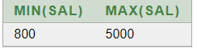

2)

select distinct sal from emp;

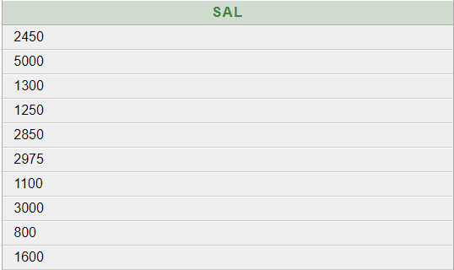

3)

select count(\*) from emp where comm is NULL

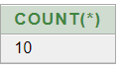

4)

SELECT SUM(sal),AVG(sal) "Average" FROM emp;

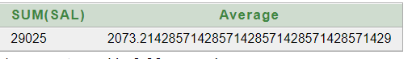

5)

select deptno,max(sal),min(sal) from emp group by deptno;

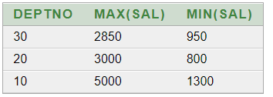

6)

select job,sum(sal),avg(sal) from emp group by job;

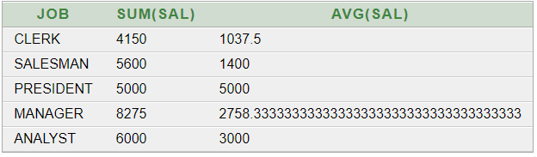

7)

select deptno from emp having max(sal)>3000 group by deptno;



8)

select job,deptno from emp group by job,deptno

having sum(sal)<2500

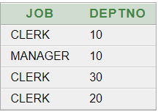

9)

select job,deptno,count(\*) "EMP" from emp group by deptno,job;

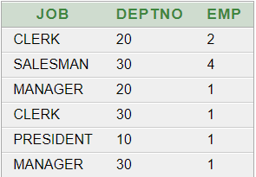

10)

select job,count(\*) from emp where job='CLERK' group by job;



11)

select deptno,count(\*) from emp group by deptno;

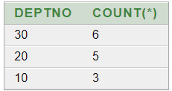

12)

select count(\*) from emp where job='CLERK' and hiredate>'01-JAN-81'



13)

select sum(sal),sum(comm) from emp;



14)

select job,(12\*(sal+NVL(comm,0))) "SAL" from emp where job='MANAGER' ;

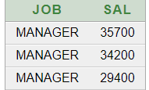

15)

SELECT AVG(sal) "Average" FROM emp WHERE job='SALESMAN';

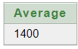

16)

select min(ename) from emp;



17)

select job,min(sal) from emp group by job;

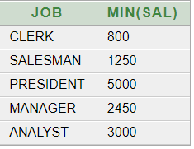

18)

select deptno,job,max(sal) from emp group by job,deptno;

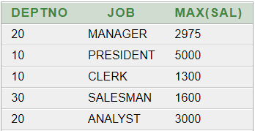

19)

select deptno,max(sal) from emp group by job,deptno having max(sal)>1500;

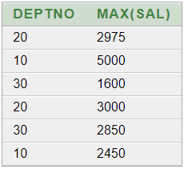

20)

select deptno,min(sal),max(sal) from emp where job='MANAGER' GROUP BY deptno;

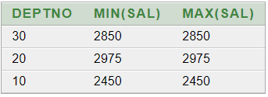

21)

select deptno,min(sal) from emp where job='MANAGER' group by deptno having min(sal)>2500 ;